Assignment 7
8.1. (Explanation will vary.) There is an entire population of possible sample means. A confidence interval is constructed to be confident that the true value of μ is contained in that interval.

8.3. The higher the confidence level, the wider the confidence interval. The larger the sample size, the shorter the confidence interval.
a. larger
b. smaller
c. smaller
d. larger

8.7 a. 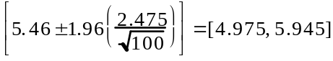

b. Yes, 95% interval is below 6.
- No, 99% interval extends above 6.
- Fairly confident since 95% CI is below 6 while 99% CI contains 6.
8.13 a. Decreases
b. Decreases
8.14 When σ is unknown, and the population you are sampling from is normal or approximately normal.

8.20 a.
b. We are at least 95% confident the mean is greater than 800 because the interval is above 800.
8.28
a. ^{units}
b.
margin of error = 1
8.32 ^{sales figures`}

